Sister Nivedita University

School of Computer Science & Engineering
Department of Computer Applications
M.Tech (CSE) 1st Semester

Data communications & Distributed Systems
Lab Manual

Prepared by Dr. Rana Majumdar

Credit Units: 2 Course Code:
Course Objectives:

Objective of the course is to provide thorough understanding & in-depth knowledge of concepts in computer networks Such as Internet protocols and routing, local area networks, wireless communications and networking, performance analysis, congestion control, TCP, network address translation, multimedia over IP, switching and routing, mobile IP, multicasting, IPv6. Peer-to-peer networking, network security, and other current research topics. A focus will be placed on wireless networking, reflecting rapid advances in this area. This course motivates the students to explore current research areas in the same field

Pre-requisites:
Student should have idea about networking, basic means of communication & applications.

Student Learning Outcomes:

- To apply the knowledge gained in areas of networking
- To create a robust network foundation in theoretical and experimental work to analyze &create computer network.
- To gain expertise in designing, implementation and development of computer based network systems and IT processes.
- To support team work with a spirit of tolerance, patience and understanding to achieve common goal through networking.
- To analyze the local and global impact of Information Technology on individuals, organizations and society.
- Create simplicity and reliability out of complexity and unreliability in networking.

List of Experiments:
- Write a C++ program to perform bit stuffing and de-stuffing
- Write a C++ program to determine if the IP address is in Class A, B, C, D, or E.
- Write a C++ program to determine if the IP address is in Class A, B, or C.
- Write a C++ program to translate dotted decimal IP address into 32 bit address.
- To establish straight configuration for LAN
- To establish rollover configuration for LAN.
- To establish crossover configuration for LAN.
- To generate hamming code.
- Write a C++ program to implement the Dijkstra Algorithm to find shortest path.
- LAN Trainer Kit
- To implement a routing protocol and check its connectivity in a variable length subnet masked network
- Using Packet tracer find out How Many Networks can be design and what would be the
I P address?
Using Packet tracer determine the number of subnets.
Using Packet tracer design an appropriate addressing scheme.
Using Packet tracer assign addresses and subnet mask pairs to device interfaces.
Using Packet tracer examine the use of the available network address space

INDEX

S.NO | LIST OF EXPERIMENTS | Page No
1 | Write a C++ program to perform bit stuffing and de-stuffing. | 21
2 | Write a C++ program to determine if the IP address is in Class A, B, C, D, or E. | 23
3 | Write a C++ program to determine if the IP address is in Class A, B, or C. | 25
4 | Write a C++ program to translate dotted decimal IP address into 32 bit address. | 26
5 | To establish straight configuration for LAN. | 28
6 | To establish rollover configuration for LAN. | 30
7 | To establish crossover configuration for LAN. | 32
8 | To generate hamming code. | 34
9 | Write a C++ program to implement the Dijkstra Algorithm to find shortest path. | 36
10 | LAN Trainer Kit | 39
11 | To implement a routing protocol and check its connectivity in a variable length subnet masked network | 49
12 | Using Packet tracer find out How Many Networks can be design and what would be the I P address? | 59
Using Packet tracer determine the number of subnets.
Using Packet tracer design an appropriate addressing scheme.
Using Packet tracer assign addresses and subnet mask pairs to device interfaces.

Using Packet tracer examine the use of the available network address space

SOFTWARE/EQUIPMENTS REQUIRED

Turbo C++

Turbo C++ was a C++ compiler and integrated development environment (IDE) originally from Borland. It allows compiling the code file programed in C++ (.cpp), even though it is also compatible with the .c extension. The first version only worked on MS-DOS, nevertheless, not long after it appeared the 3.0 and 3.1 (considered the most stable) that already works on Windows.
The last release of this sturdy compiler was the 4.5. Finally, in the mid 90's, Turbo C++ was substituted by other more modern compilers like C++ Builder.
Turbo C++ 4.5 offers a humble graphic interface from which to develop small applications and carry out the compilation process to be able to obtain the executable files. In comparison with earlier versions, it has the advantage of being able to use the mouse to move around the menus and to select the options.

RJ -45 connectors

RJ delivers Ethernet in any environment that is subject to constant vibrations and shocks, heat, cold, dust, water or oil. It complies with the requirements of the IP67 protection index as specified by IEC 60529.

RJ-45S: Is a single-line data jack normally associated with programmed (P) modems.
RJ-45M: Provide a multiple-mounting arrangement for mounting a number of RJ-41S or RJ-45S Single-Line Universal or Programmed data jacks.

Twisted pair cable
Twisted pair cabling is a type of wiring in which two conductors (the forward and return conductors of a single circuit) are twisted together for the purposes of canceling out electromagnetic interference (EMI) from external sources; for instance, electromagnetic radiation from unshielded twisted pair (UTP) cables, and crosstalk between neighboring pairs. It was invented by Alexander Graham Bell.
Gripping or Crimping tool
Crimping is joining two pieces of metal or other malleable material by deforming one or both of them to hold the other. The bend or deformity is called the crimp.
Cisco Packet Tracer: A simulation tool designed by Cisco.

Network Commands on Linux / Unix

ARP

Objective: Display or Manipulate the ARP information on a network device or computer.

Arp :

USAGE: When we need an Ethernet (MAC) address we can use arp(address resolution protocol).

In other words it shows the physical address of a host.

Example:

C:\Documents and Settings\sysadm>arp -a

Output:

Interface: 169.254.195.199 --- 0x2

Internet Address Physical Address Type

216.109.127.60 00-53-45-00-00-00 static

FINGER

Objective: The finger command available in Unix / Linux variants allows a user to find sometimes personal information about a user. This information can include the last time the user logged in, when they read their e-mail, etc... If the user creates a .PLAN or other related file the user can also display additional information.

finger:

USAGE: Displays the information about a user on the system.

Example:

[hilmiolgun@ssh hilmiolgun]$ finger

Output:

Login Name Tty Idle Login Time Office Office Phone

adel Adel Abu-Sharkh pts/1 7 Sep 10 00:11 (cpe.atm2-0-1091080.0x50a0bcb2.albnxx13.customer.tele.dk)

adel Adel Abu-Sharkh pts/2 9 Sep 9 23:56 (cpe.atm2-0-1091080.0x50a0bcb2.albnxx13.customer.tele.dk)

hilmiolgun Hilmi Olgun pts/9 Sep 10 00:20 (0x3ef3e2fe.albnxx8.adsl.tele.dk)

hm Hanne Munkholm pts/6 1:56 Sep 8 21:27 (off180.palombia.dk)

jcg Jens Christian Godsk pts/4 1d Sep 8 10:28 (toscana.itu.dk)

kaj Kenneth Ahn Jensen pts/7 Sep 10 00:11 (cpe.atm2-0-54493.0x50a4ad32.boanxx12.customer.tele.dk)

root root pts/8 1 Sep 10 00:12 (sysadm2.itu.dk)

troels Troels Arvin pts/5 3:49 Sep 9 20:31 (62.79.119.132.adsl.vbr.worldonline.dk)

webclaus Claus Bech Rasmussen pts/0 6 Sep 10 00:11 (port967.ds1-khk.adsl.cybercity.dk)

IMPORTANT NOTE : Check the online users, and get a list of them(above).

Then just choose any one user to get further information .(below)

[hilmiolgun@ssh hilmiolgun]$ finger hm

Login: hm Name: Hanne Munkholm

Directory: /import/home/hm Shell: /bin/bash

On since Mon Sep 8 21:27 (CEST) on pts/6 from off180.palombia.dk

1 hour 56 minutes idle

Last login Tue Sep 9 11:05 (CEST) on pts/12 from stud127.itu.dk
New mail received Mon Nov 11 23:01 2002 (CET)

Unread since Sat Oct 5 00:00 2002 (CEST)

Plan:

World Domination... fast.

[hilmiolgun@ssh hilmiolgun]$

HOSTNAME

Objective: The hostname command displays the host name of the Windows XP computer currently logged into.

IPCONFIG

Objective: Ipconfig is a MS-DOS utility that can be used from MS-DOS and a MS-DOS shell to display the network settings currently assigned and given by a network. This command can be utilized to verify a network connection as well as to verify your network settings.

Windows 2000 users should use this command to determine network information.

PATHPING

Objective: Pathping is a MS-DOS utility available for Microsoft Windows 2000 and Windows XP users. This utility enables a user to find network latency and network loss.

PING

Objective: Ping is one of the most commonly used and known commands. Ping allows a user to ping another network IP address. This can help determine if the network is able to communicate with the network.

ping:

USAGE: Simpy shows if the remote machine is available or not....

Example:

C:\Documents and Settings\sysadm>ping webmail.itu.dk

Output:

Pinging tarzan.itu.dk [130.226.133.3] with 32 bytes of data:

Reply from 130.226.133.3: bytes=32 time=29ms TTL=55

Reply from 130.226.133.3: bytes=32 time=30ms TTL=55

Reply from 130.226.133.3: bytes=32 time=30ms TTL=55

Reply from 130.226.133.3: bytes=32 time=30ms TTL=55

Ping statistics for 130.226.133.3:

Packets: Sent = 4, Received = 4, Lost = 0 (0% loss),

Approximate round trip times in milli-seconds:

Minimum = 29ms, Maximum = 30ms, Average = 29ms

IMPORTANT NOTE "Request time out" which means the remote machine is not working well.(Not answering)

NBTSTAT

Objective: The nbtstat MS-DOS utility that displays protocol statistics and current TCP/IP connections using NBT.

NET

Objective: The net command is available in MS-DOS / Windows and is used to set, view and determine network settings.

NETSTAT

Objective: The netstat command is used to display the TCP/IP network protocol statistics and information.

NSLOOKUP

Objective: The nslookup MS-DOS utility that enables a user to do a reverse lookup on an IP address of a domain or host on a network.

Nslookup:

USAGE: Displays information from Domain Name System (DNS) name servers.

Example:

C:\Documents and Settings\sysadm>nslookup itu.dk

Output

Server: ns3.inet.tele.dk

Address: 193.162.153.164

Non-authoritative answer:

Name: itu.dk

Address: 130.226.133.2

IMPORTANT NOTE: By default this command display pc's server name .

C:\Documents and Settings\sysadm>nslookup mail.yahoo.com itu.dk

Output

Server: superman.itu.dk

Address: 130.226.133.2

Non-authoritative answer:

Name: login.yahoo.akadns.net

Address: 216.109.127.60

Aliases: mail.yahoo.com, login.yahoo.com

IMPORTANT NOTE: Remark that in the second example we do not see the default server name.

ROUTE

Objective: The route MS-DOS utility enables computers to view and modify the computer's route table.

TRACERT / TRACEROUTE

Objective: The tracert command in MS-DOS / Windows or the traceroute command in Unix / Linux and variants is another commonly used network command to help determine network related issues or slowdowns. Using this command you can view a listing of how a network packet travels through the network and where it may fail or slow down. Using this information you can determine the computer, router, switch or other network device possibly causing your network issues.

tracert:

USAGE It simply shows the path between source and destination address.

Example:
C:\Documents and Settings\sysadm>tracert webmail.itu.dk

Output

Tracing route to tarzan.itu.dk [130.226.133.3]

over a maximum of 30 hops:

1 * * * Request timed out.

2 29 ms 19 ms 29 ms ge-0-2-1-2.1000M.albnxu1.ip.tele.dk [195.249.1.2

9]

3 29 ms 29 ms 19 ms pos1-0.622M.lynxg1.ip.tele.dk [195.249.2.46]

4 29 ms 19 ms 29 ms herman.fsknet.lyngby.forskningsnettet.dk [192.38

.7.1]

5 29 ms 29 ms 19 ms 130.225.244.214

6 29 ms 29 ms 29 ms 1.ku.forskningsnettet.dk [130.225.245.90]

7 29 ms 29 ms 29 ms rk.itu.forskningsnettet.dk [130.226.249.30]

8 29 ms 29 ms 29 ms 130.225.245.86

9 29 ms 29 ms 29 ms tarzan.itu.dk [130.226.133.3]

Trace complete.

WHOIS

Objective The whois command available in Unix / Linux variants helps allow a user to identify a domain name. This command provides information about a domain name much like the WHOIS on network solutions. In some cases the domain information will be provided from Network Solutions.

WINIPCFG

Objective The winipcfg command available in Windows allows a user to display network and network adapter information. Here, a user can find such information as an IP address, Subnet Mask, Gateway, etc...

IMPORTANT NOTE: Windows 2000, Windows XP and above users do not have winipcfg. Instead, use ipconfig.

POINTS TO BE NOTED: Firstly most of those commands run on any operating system (UNIX, Solaris, windows).And to test those commands the TCP/IP protocol must be installed on the system(Generally it is already installed).And some services must be started, to do that(assuming that you are using windows2000 or XP) from control panelàadministrative toolsàservices you can start/stop any services from there manually or automatically.

About this document each time when you see the line “C:\Documents and Settings\sysadm>” it means that we are using(on) command prompt-line. And additionally remember that each command belongs(or works under) to a protocol and it is possible that you might have not learnt those protocols until now ,DON’T WORRY you will learn each protocol when the time arrives. The aim of this document is to give you some knowledge about network commands.

FTP:

Objective For file transferring..(File transfer protocol)

USAGE: Lets you dont have an ftp software and you want to get a file from your school harddisk.

So to do that:

C:\Documents and Settings\sysadm>ftp

ftp> open

To ftp.itu.dk

Output

Connected to ssh.itu.dk.
220 ProFTPD 1.2.8rc2 Server (ProFTPD Default Installation) [ssh.it-c.dk]

NOTE: What am I doing is simply:typing them one-by-one(after each typing remember to enter)

ftp,open,ftp.itu.dk

User (ssh.itu.dk:(none)): hilmiolgun

331 Password required for hilmiolgun.

Password:

230 User hilmiolgun logged in.

NOTE:The server will require username and password..

ftp> help

Output

Commands may be abbreviated. Commands are:

! delete literal prompt send

? debug ls put status

append dir mdelete pwd trace

ascii disconnect mdir quit type

bell get mget quote user

binary glob mkdir recv verbose

bye hash mls remotehelp

cd help mput rename

close lcd open rmdir

ftp> help dir

Output

dir List contents of remote directory

NOTE: If it is your first time to those commands just type help and get the commands.If you dont know how to use

them type help commandname..
ftp> dir

200 PORT command successful

150 Opening ASCII mode data connection for file list

drwx------ 4 hilmiolgun hilmiolgun 155 Jul 1 14:02 Desktop

drwx------ 2 hilmiolgun hilmiolgun 4096 May 30 10:21 Mail

drwxr-xr-x 5 hilmiolgun hilmiolgun 90 Sep 2 02:59 MobilePositionSDK

drwx------ 7 hilmiolgun hilmiolgun 4096 Aug 8 2002 NTnetscape

drwxr--r-- 13 hilmiolgun hilmiolgun 4096 Sep 4 01:56 New Folder

-rw-rw-r-- 1 hilmiolgun hilmiolgun 74 Sep 9 12:56 TTI409B

drwx------ 2 hilmiolgun hilmiolgun 6 Jan 21 2002 cgi-bin

-rw-rw-r-- 1 hilmiolgun hilmiolgun 74 Sep 9 12:56 geu

-rw-rw-r-- 1 hilmiolgun hilmiolgun 74 Sep 9 12:56 hilmiolgun

drwxr-xr-x 6 hilmiolgun hilmiolgun 4096 Aug 14 15:59 image

drwxr-xr-x 3 hilmiolgun hilmiolgun 4096 Jul 29 16:03 jmf20-apidocs

drwxr-xr-x 4 hilmiolgun hilmiolgun 4096 Sep 9 14:10 NOTEsieee

drwx------ 2 hilmiolgun hilmiolgun 6 Feb 21 2002 nsmail

drwx------ 3 hilmiolgun hilmiolgun 103 Feb 21 2002 office52

drwx------ 2 hilmiolgun hilmiolgun 6 Jan 21 2002 private

drwxr--rwx 2 hilmiolgun hilmiolgun 4096 Aug 23 12:02 public_html

drwxr-xr-x 5 hilmiolgun hilmiolgun 4096 Sep 6 03:30 speech

-rw-rw-r-- 1 hilmiolgun hilmiolgun 2630 Sep 9 13:58 test.txt

-rw-rw-r-- 1 hilmiolgun hilmiolgun 148 Sep 9 14:03 testing.txt

226 Transfer complete.

ftp: 1318 bytes received in 0,24Seconds 5,49Kbytes/sec.

ftp> get testing.txt

Output

200 PORT command successful

150 Opening ASCII mode data connection for testing.txt (148 bytes)

226 Transfer complete.

ftp: 161 bytes received in 0,02Seconds 8,05Kbytes/sec.

NOTE :After taking a look to the school harddisk ,I copied a file "testing.txt" to my local harddisk....

ftp> !dir

Output

Volume in drive C has no label.

Volume Serial Number is 0868-D52D

Directory of C:\Documents and Settings\sysadm

10-09-2003 00:21 <DIR> .

10-09-2003 00:21 <DIR> ..

31-08-2003 07:28 <DIR> .java

25-04-2003 12:18 <DIR> .javaws

23-04-2003 15:26 <DIR> .jpi_cache

26-08-2003 04:59 <DIR> .Nokia

07-09-2003 01:46 12.546 .plugin140_03.trace

07-09-2003 04:46 693 .plugin141_02.trace

07-09-2003 01:20 164 .saves-3824-IBMR31IMAGE

07-09-2003 01:20 <DIR> Desktop

07-09-2003 08:05 <DIR> Favorites

06-09-2003 05:29 80.140 love.wav

09-09-2003 23:45 <DIR> mindterm

09-09-2003 11:02 <DIR> My Documents

10-09-2003 00:21 2.903 plugin131_08.trace

25-04-2003 11:44 <DIR> Start Menu

06-09-2003 21:21 <DIR> studio5se_user

06-09-2003 05:32 18 test.txt

06-09-2003 05:20 70 testing

10-09-2003 00:37 161 testing.txt

26-08-2003 03:46 <DIR> WINDOWS

8 File(s) 96.695 bytes

13 Dir(s) 3.842.056.192 bytes free

ftp> send love.wav

Output

200 PORT command successful

150 Opening ASCII mode data connection for love.wav

226 Transfer complete.

ftp: 80140 bytes sent in 3,97Seconds 20,21Kbytes/sec.

ftp> dir

Output

200 PORT command successful

150 Opening ASCII mode data connection for file list

drwx------ 4 hilmiolgun hilmiolgun 155 Jul 1 14:02 Desktop

drwx------ 2 hilmiolgun hilmiolgun 4096 May 30 10:21 Mail

drwxr-xr-x 5 hilmiolgun hilmiolgun 90 Sep 2 02:59 MobilePositionSDK

drwx------ 7 hilmiolgun hilmiolgun 4096 Aug 8 2002 NTnetscape

drwxr--r-- 13 hilmiolgun hilmiolgun 4096 Sep 4 01:56 New Folder

-rw-rw-r-- 1 hilmiolgun hilmiolgun 74 Sep 9 12:56 TTI409B

drwx------ 2 hilmiolgun hilmiolgun 6 Jan 21 2002 cgi-bin

-rw-rw-r-- 1 hilmiolgun hilmiolgun 74 Sep 9 12:56 geu

-rw-rw-r-- 1 hilmiolgun hilmiolgun 74 Sep 9 12:56 hilmiolgun

drwxr-xr-x 6 hilmiolgun hilmiolgun 4096 Aug 14 15:59 image

drwxr-xr-x 3 hilmiolgun hilmiolgun 4096 Jul 29 16:03 jmf20-apidocs

-rw-rw-r-- 1 hilmiolgun hilmiolgun 80137 Sep 9 22:36 love.wav

drwxr-xr-x 4 hilmiolgun hilmiolgun 4096 Sep 9 14:10 NOTEsieee

drwx------ 2 hilmiolgun hilmiolgun 6 Feb 21 2002 nsmail

drwx------ 3 hilmiolgun hilmiolgun 103 Feb 21 2002 office52

drwx------ 2 hilmiolgun hilmiolgun 6 Jan 21 2002 private

drwxr--rwx 2 hilmiolgun hilmiolgun 4096 Aug 23 12:02 public_html

drwxr-xr-x 5 hilmiolgun hilmiolgun 4096 Sep 6 03:30 speech

-rw-rw-r-- 1 hilmiolgun hilmiolgun 2630 Sep 9 13:58 test.txt

-rw-rw-r-- 1 hilmiolgun hilmiolgun 148 Sep 9 14:03 testing.txt

226 Transfer complete.

ftp: 1387 bytes received in 0,07Seconds 19,81Kbytes/sec.

ftp>

NOTE:At the end first looking at the local working directory and sending a file "love.wav" to the school harddisk.

NET:

Objective It has many options, which are for checking/starting/stopping nt services, users, messaging, configuration and so on.Some of those options require administration privileges.

USAGE : To have an overview of commands options....

C:\Documents and Settings\sysadm>net

The syntax of this command is:

NET [ ACCOUNTS | COMPUTER | CONFIG | CONTINUE | FILE | GROUP | HELP |

HELPMSG | LOCALGROUP | NAME | PAUSE | PRINT | SEND | SESSION |

SHARE | START | STATISTICS | STOP | TIME | USE | USER | VIEW ]

NOTE: And furthermore to get an overview of a specific option ...

C:\Documents and Settings\sysadm>net help print

The syntax of this command is:

NET PRINT

\\computername\sharename

[\\computername] job# [/HOLD | /RELEASE | /DELETE]

NET PRINT displays print jobs and shared queues.

For each queue, the display lists jobs, showing the size

and status of each job, and the status of the queue.

\\computername Is the name of the computer sharing the printer

queue(s).

sharename Is the name of the shared printer queue.

job# Is the identification number assigned to a print

job. A computer with one or more printer queues

assigns each print job a unique number.

/HOLD Prevents a job in a queue from printing.

The job stays in the printer queue, and other

jobs bypass it until it is released.

/RELEASE Reactivates a job that is held.

/DELETE Removes a job from a queue.

NET HELP command | MORE displays Help one screen at a time.

TELNET:

Objective: Telnet is a simple, text-based program you can use to connect to another computer by using the Internet. Using Telnet, you can enter commands to access programs and services that are on the remote computer

telnet
USAGE: Establish a Telnet connection with a host computer or remote server.
Example:
telnet server.net 80
Output:
NOP | No operation.
Data Mark | The data stream portion of a Synch. This should always be accompanied by a TCP Urgent notification.
Break | NVT character BRK.
Interrupt Process | The function IP.
Abort output | The function AO.
Are You There | The function AYT.
Erase character | The function EC.
Erase Line | The function EL.
Go ahead | The GA signal.
SB | Indicates that what follows is subnegotiation of the indicated option.
WILL (option code) | Indicates the desire to begin performing, or confirmation that you are now performing, the indicated option.
WON'T (option code) | Indicates the refusal to perform, or continue performing, the indicated option.
DO (option code) | Indicates the request that the other party perform, or confirmation that you are expecting the other party to perform, the indicated option.
DON'T (option code) | Indicates the demand that the other party stop performing, or confirmation that you are no longer expecting the other party to perform, the indicated option.
IAC

EXPERIMENT NO.-1
PROBLEM: Write a C++ program to perform bit stuffing and de-stuffing.
OBJECTIVE: To perform bit stuffing and de-stuffing.
SOFTWARE USED: Turbo C++.
THEORY: In data transmission and telecommunication, bit stuffing (also known—uncommonly—as positive justification) is the insertion of non information bits into data. Stuffed bits should not be confused with overhead bits. De-stuffing is opposite of bit-stuffing.
SOLUTION:
#include<iostream.h>
#include<conio.h>
#include<stdio.h>
void main()
{
clrscr();
int a[20],i=0,k=0,count=0; //count is a variable to count the number of 1's.
cout<<"Enter the elements of the array(in 1's and 0's form)";
for(i=0;i<10;i++)
cin>>a[i];
cout<<"\n The array entered is";
for(i=0;i<10;i++)
cout<<a[i];
i=0;
while(i!=9) // Performing Bit-Stuffing.
{
if(a[i]==1)
{
i++;
count++;
if(count==5)
{
for(k=11;k>i;k--)
a[k]=a[k-1];
a[i]=0;
}
}
else
{
i++;
count=0;
}
}
cout<<"\n"<<"The array after stuffing is: ";

for(i=0;i<=10;i++)
cout<<a[i];
cout<<"\n"<<"The array after destuffing is: ";
i=0;
while (i<10) // Performing Destuffing.
{
if(a[i]==1)
{
i++;
count++;
if(count==5)
{
for(k=i;k<11;k++)
a[k]=a[k+1];
}
}
else
{
i++;
count=0;
}
}
for(i=0;i<10;i++)
cout<<a[i];
getch();
}
OUTPUT:-
Enter the elements of the array(in 1’s and 0’s form)1
1
1
1
1
1
0
0
1
0
The array entered is 1111110010

The array after stuffing is: 11111010010

The array after destuffing is: 1111110010

EXPERIMENT NO.-2

PROBLEM: Write a C++ program to determine if the IP address is in Class A, B, C, D, or E.
OBJECTIVE: To determine if the IP address is in Class A, B, C, D, or E.
SOFTWARE USED: Turbo C++.
THEORY: An Internet Protocol address (IP address) is a numerical label assigned to each device (e.g., computer, printer) participating in a computer network that uses the Internet Protocol for communication. An IP address serves two principal functions: host or network interface identification and location addressing. Its role has been characterized as follows: "A name indicates what we seek. An address indicates where it is. A route indicates how to get there."
The designers of the Internet Protocol defined an IP address as a 32-bit number and this system, known as Internet Protocol Version 4 (IPv4), is still in use today. However, due to the enormous growth of the Internet and the predicted depletion of available addresses, a new addressing system (IPv6), using 128 bits for the address, was developed in 1995.
SOLUTION:
// To determine if the IP address is in Class A, B, C, D or E.
#include<iostream.h>
#include<conio.h>
#include<stdio.h>
void main()
{
clrscr();
int a[4],i=0;
cout<<"Enter The IP address";
for(i=0;i<4;i++)
cin>>a[i];
cout<<"\n IP ADDRESS:"<<a[0]<<"."<<a[1]<<"."<<a[2]<<"."<<a[3]<<"\n";
cout<<"The IP address is in Class: ";
if(a[0]>=0 && a[0]<=127)
cout<<"Class A";
if(a[0]>127 && a[0]<191)
cout<<"Class B";
if(a[0]>191 && a[0]<224)
cout<<"Class C";
if(a[0]>224 && a[0]<=239)
cout<<"Class D";
if(a[0]>239)
cout<<"Class E";
getch();
}
OUTPUT:
Enter The IP address128
65
96
215
IP ADDRESS: 128.65.96.215
The IP address is in Class: Class B

EXPERIMENT NO.-3
PROBLEM: Write a C++ program to determine if the IP address is in Class A, B, or C.
OBJECTIVE: To determine if the IP address is in Class A, B, or C.
SOFTWARE USED: Turbo C++.
THEORY: An Internet Protocol address (IP address) is a numerical label assigned to each device (e.g., computer, printer) participating in a computer network that uses the Internet Protocol for communication. An IP address serves two principal functions: host or network interface identification and location addressing.
SOLUTION:
// To determine if the IP adress is in Class A, B, or C.
#include<iostream.h>
#include<conio.h>
#include<stdio.h>
void main()
{
clrscr();
int a[4],i=0;
cout<<"Enter The IP adress";
for(i=0;i<4;i++)
cin>>a[i];

if(a[0]>=0 && a[0]<=127)
cout<<"Class A";
if(a[0]>127 && a[0]<191)
cout<<"Class B";
if(a[0]>191)
cout<<"Class C";

cout<<"\nIP ADRESS:"<<a[0]<<"."<<a[1]<<"."<<a[2]<<"."<<a[3];
getch();
}
OUTPUT:
Enter The IP address12
65
96
215
IP ADDRESS: 12.65.96.215
The IP address is in Class: Class A

EXPERIMENT NO.-4
PROBLEM: Write a C++ program to translate dotted decimal IP address into 32 bit address.
OBJECTIVE: To translate dotted decimal IP address into 32 bit address.
SOFTWARE USED: Turbo C++.
THEORY: An Internet Protocol address (IP address) is a numerical label assigned to each device (e.g., computer, printer) participating in a computer network that uses the Internet Protocol for communication. An IP address serves two principal functions: host or network interface identification and location addressing.
The designers of the Internet Protocol defined an IP address as a 32-bit number and this system, known as Internet Protocol Version 4 (IPv4), is still in use today. However, due to the enormous growth of the Internet and the predicted depletion of available addresses, a new addressing system (IPv6), using 128 bits for the address, was developed in 1995.
SOLUTION:
//Write a program to translate dotted decimal IP address into 32 bit address
#include<iostream.h>
#include<conio.h>
void main()
{
clrscr();
int i,j,a[4],bin[8]={128,64,32,16,8,4,2,1};
cout<<"Enter the ip address";
for(i=0;i<4;i++)
cin>>a[i];
cout<<"The ip address is:-"<<a[0]<<"."<<a[1]<<"."<<a[2]<<"."<<a[3]<<endl;
for(i=0;i<4;i++)
{
for(j=0;j<8;j++)
{
if (a[i]&bin[j])
cout<<1;
else
cout<<0;
}
cout<<".";
}
getch();
}
OUTPUT:
Enter the ip address123
32
68
7
The ip address is:-123.32.68.7
The IP address in binary form is:-
01111011.00100000.01000100.00000111.

EXPERIMENT NO.-5
PROBLEM: To establish straight configuration for LAN.
OBJECTIVE: To establish straight configuration for LAN.
EQUIPMENTS REQUIRED:-
- 2 RJ -45 connectors
- Twisted pair cable
- Gripping or Crimping tool
- SLT-Tool
Colour Coding:-
- Orange white
- Orange
- Green white
- Blue
- Blue white
- Green
- Brown white
- Brown
Straight Configuration:- 1---------------------------------------------1
2---------------------------------------------2
3---------------------------------------------3
4---------------------------------------------4
5---------------------------------------------5
6---------------------------------------------6
7---------------------------------------------7
8---------------------------------------------8

THEORY: A local area network (LAN) is a computer network that connects computers and devices in a limited geographical area such as home, school, computer laboratory or office building. The defining characteristics of LANs, in contrast to wide area networks (WANs), include their usually higher data-transfer rates, smaller geographic area, and lack of a need for leased telecommunication lines.
ARCNET, Token Ring and other technology standards have been used in the past, but Ethernet over twisted pair cabling, and Wi-Fi are the two most common technologies currently in use.
PROCEDURE:-
The outer covering of the wire is peeled off and according to requirement the wires are inserted in RJ-45 connector and punched with the help of punching tool after punching the wire is tested with SLT( Side locator tool).
RESULT:-
The straight wiring for the LAN has been established and tested using SLT tool.
USE:-
This type of wiring is used for connecting to PC or Hub.

EXPERIMENT NO.-6
PROBLEM: To establish rollover configuration for LAN.
OBJECTIVE: To establish rollover configuration for LAN.
EQUIPMENTS REQUIRED:-
- 2 RJ -45 connectors
- Twisted pair cable
- Gripping or Crimping tool
- SLT-Tool
Colour Coding:-
- Orange white
- Orange
- Green white
- Blue
- Blue white
- Green
- Brown white
- Brown
Rollover Configuration:- 1---------------------------------------------8
2---------------------------------------------7
3---------------------------------------------6
4---------------------------------------------5
5---------------------------------------------4
6---------------------------------------------3
7---------------------------------------------2
8---------------------------------------------1

THEORY: A local area network (LAN) is a computer network that connects computers and devices in a limited geographical area such as home, school, computer laboratory or office building. The defining characteristics of LANs, in contrast to wide area networks (WANs), include their usually higher data-transfer rates, smaller geographic area, and lack of a need for leased telecommunication lines.
ARCNET, Token Ring and other technology standards have been used in the past, but Ethernet over twisted pair cabling, and Wi-Fi are the two most common technologies currently in use.
PROCEDURE:-
The outer covering of the wire is peeled off and according to requirement the wires are inserted in RJ-45 connector and punched with the help of punching tool after punching the wire is tested with SLT( Side locator tool).
RESULT:-
The rollover wiring for the LAN has been established and tested using SLT tool.
USE:-
This type of wiring is used for configuration of the router.

EXPERIMENT NO.-7
PROBLEM: To establish crossover configuration for LAN.
OBJECTIVE: To establish crossover configuration for LAN.
EQUIPMENTS REQUIRED:-
- 2 RJ -45 connectors
- Twisted pair cable
- Gripping or Crimping tool
- SLT-Tool
Colour Coding:-
- Orange white
- Orange
- Green white
- Blue
- Blue white
- Green
- Brown white
- Brown
Crossover Configuration:- 1---------------------------------------------3
2---------------------------------------------6
3---------------------------------------------1
4---------------------------------------------4
5---------------------------------------------5
6---------------------------------------------2
7---------------------------------------------7
8---------------------------------------------8
THEORY: A local area network (LAN) is a computer network that connects computers and devices in a limited geographical area such as home, school, computer laboratory or office building. The defining characteristics of LANs, in contrast to wide area networks (WANs), include their usually higher data-transfer rates, smaller geographic area, and lack of a need for leased telecommunication lines.
ARCNET, Token Ring and other technology standards have been used in the past, but Ethernet over twisted pair cabling, and Wi-Fi are the two most common technologies currently in use.
PROCEDURE:-
The outer covering of the wire is peeled off and according to requirement the wires are inserted in RJ-45 connector and punched with the help of punching tool after punching the wire is tested with SLT (Side locator tool).
RESULT:-
The crossover wiring for the LAN has been established and tested using SLT tool.
USES:
This type of wiring is used for connecting PC to another PC.

EXPERIMENT NO.-8
PROBLEM: To generate hamming code.
OBJECTIVE: To generate hamming code.
SOFTWARE USED: Turbo C++.
THEORY: In telecommunication, a Hamming code is a linear error-correcting code named after its inventor, Richard Hamming. Hamming codes can detect up to two simultaneous bit errors, and correct single-bit errors; thus, reliable communication is possible when the Hamming distance between the transmitted and received bit patterns is less than or equal to one. By contrast, the simple parity code cannot correct errors, and can only detect an odd number of errors.
In mathematical terms, Hamming codes are a class of binary linear codes. For each integer there is a code with m parity bits and 2^{m} − m − 1 data bits. The parity-check matrix of a Hamming code is constructed by listing all columns of length m that are pairwise independent. Hamming codes are an example of perfect codes, codes that exactly match the theoretical upper bound on the number of distinct code words for a given number of bits and ability to correct errors.
Because of the simplicity of Hamming codes, they are widely used in computer memory (RAM). In particular, a single-error-correcting and double-error-detecting variant commonly referred to as SECDED.
SOLUTION:
#include <iostream.h>
#include<conio.h>
void main ( )
{
int a0, a1, a2, a3, b0, b1, b2, b3, r0, r1, r2, s0, s1, s2, q0, q1, q2, q3;
cout<< "Enter the word\n";
cin>>a3>>a2>>a1>>a0;
r0= (a0+a1+a2) %2;
r1= (a1+a2+a3) %2;
r2= (a0+a1+a3) %2;
cout <<"The code at sender is: "<<a3<<a2<<a1<<a0<<r2<<r1<<r0;
cout<<"\n Enter the code at receiver:\n";
cin>>b3>>b2>>b1>>b0>>q2>>q1>>q0;
cout<<"b3="<<b3<<",b2="<<b2<<",b1="<<b1<<",b0="<<b0<<",q2="<<q2<<",q1="<<q1<<",q0="<<q0;
s0= (b2+b1+b0+q0) %2;
s1= (b3+b2+b1+q1) %2;
s2= (b1+b0+b3+q2) %2;
cout<<"\n"<<"s2="<<s2<<",s1="<<s1<<",s0="<<s0;
if ( s2==0 && s1==0 && s0==0 )
cout << "\n No Error";
else if ( s2==0 && s1==0 && s0==1 )
cout << "\n Error at q0";
else if ( s2==0 && s1==1 && s0==0 )
cout << "\n Error at q1";
else if ( s2==0 && s1==1 && s0==1 )
cout << "\n Error at b2";
else if ( s2==1 && s1==0 && s0==0 )
cout << "\n Error at q2";
else if ( s2==1 && s1==0 && s0==1 )
cout << "\n Error at b0";
else if ( s2==1 && s1==1 && s0==0 )
cout << "\n Error at b3";
else if ( s2==1 && s1==1 && s0==1 )
cout << "\n Error at b1";
getch();
clrscr();
}

OUTPUT:
Enter the word
1
1
0
1
The code at sender is: 1101000

Enter the code at receiver:1
0
1
1
0
1
0
b3=1,b2=0,b1=1,b0=1,q2=0,q1=1,q0=0
s2=1,s1=1,s0=0
Error at b3

EXPERIMENT NO.-9
PROBLEM: Write a C++ program to implement the Dijkstra Algorithm to find shortest path.
OBJECTIVE: To implement the Dijkstra Algorithm to find shortest path.
SOFTWARE USED: Turbo C++.
THEORY: Dijkstra's algorithm, conceived by Dutch computer scientist Edsger Dijkstra in 1956 and published in 1959,^{[1][2]} is a graph search algorithm that solves the single-source shortest path problem for a graph with nonnegative edge path costs, producing a shortest path tree. This algorithm is often used in routing and as a subroutine in other graph algorithms.
For a given source vertex (node) in the graph, the algorithm finds the path with lowest cost (i.e. the shortest path) between that vertex and every other vertex. It can also be used for finding costs of shortest paths from a single vertex to a single destination vertex by stopping the algorithm once the shortest path to the destination vertex has been determined.
For example, if the vertices of the graph represent cities and edge path costs represent driving distances between pairs of cities connected by a direct road, Dijkstra's algorithm can be used to find the shortest route between one city and all other cities. As a result, the shortest path first is widely used in network routing protocols, most notably IS-IS and OSPF (Open Shortest Path First).
SOLUTION:
// To implement Dijkstra’s Algorithm.
#include<stdio.h>
#include<conio.h>
#include<process.h>
#include<string.h>
#include<math.h>
#define IN 99
#define N 6
int dijkstra(int cost[][N],int source,int target);
void main()
{
int cost[N][N],i,j,w,ch,co;
int source,target,x,y;
clrscr();
printf("Shortest path algorithm DIJKSTRA'S ALGORITHM \n\n");
for(i=1;i<N;i++)
{
for(j=1;j<N;j++)
{
cost[i][j]=IN;
}
}
for(x=1;x<N;x++)
{
for(y=x+1;y<N;y++)
{
printf("Enter the weight of the path between node %d and %d:",x,y);
scanf("%d",&w);
cost[x][y]=cost[y][x]=w;
}
printf("\n");
}
printf("\n Enter the source:");
scanf("%d",&source);
printf("\n Enter the target");
scanf("%d",&target);
co=dijsktra(cost,source,target);
printf("\n shortest path:%d",co);
getch();
}
int dijsktra(int cost[][N],int source,int target)
{
int dist[N],prev[N],selected[N]={0},i,m,min,start,d,j;
char path[N];
for(i=1;i<N;i++)
{
dist[i]=IN;
prev[i]=-1;
}
start=source;
selected[start]=1;
dist[start]=0;
while(selected[target]==0)
{
min=IN;m=0;
for(i=1;i<N;i++)
{
d=dist[start]+cost[start][i];
if(d<dist[i] && selected[i]==0)
{
dist[i]=d;
prev[i]=start;
}
if(min>dist[i] && selected[i]==0)
{
min=dist[i];
m=i;
}
}
start=m;
selected[start]=1;
}
start=target;
j=0;
while(start!=-1)
{
path[j++]=start+65;
start=prev[start];
}
path[j]='\0';
strrev(path);
printf("%s",path);
return dist[target];
}

OUTPUT:
Shortest path algorithm DIJKSTRA'S ALGORITHM
Enter weight of the path between node 1 and 2:2
Enter weight of the path between node 1 and 3:1
Enter weight of the path between node 1 and 4:4
Enter weight of the path between node 1 and 5:5
Enter weight of the path between node 2 and 3:5
Enter weight of the path between node 2 and 4:2
Enter weight of the path between node 2 and 5:3
Enter weight of the path between node 3 and 4:1
Enter weight of the path between node 3 and 4:4
Enter weight of the path between node 4 and 5:5
Enter the source:2
Enter the target:4
CE
Shortest path:2

EXPERIMENT NO.-10

LAN TRAINER KIT
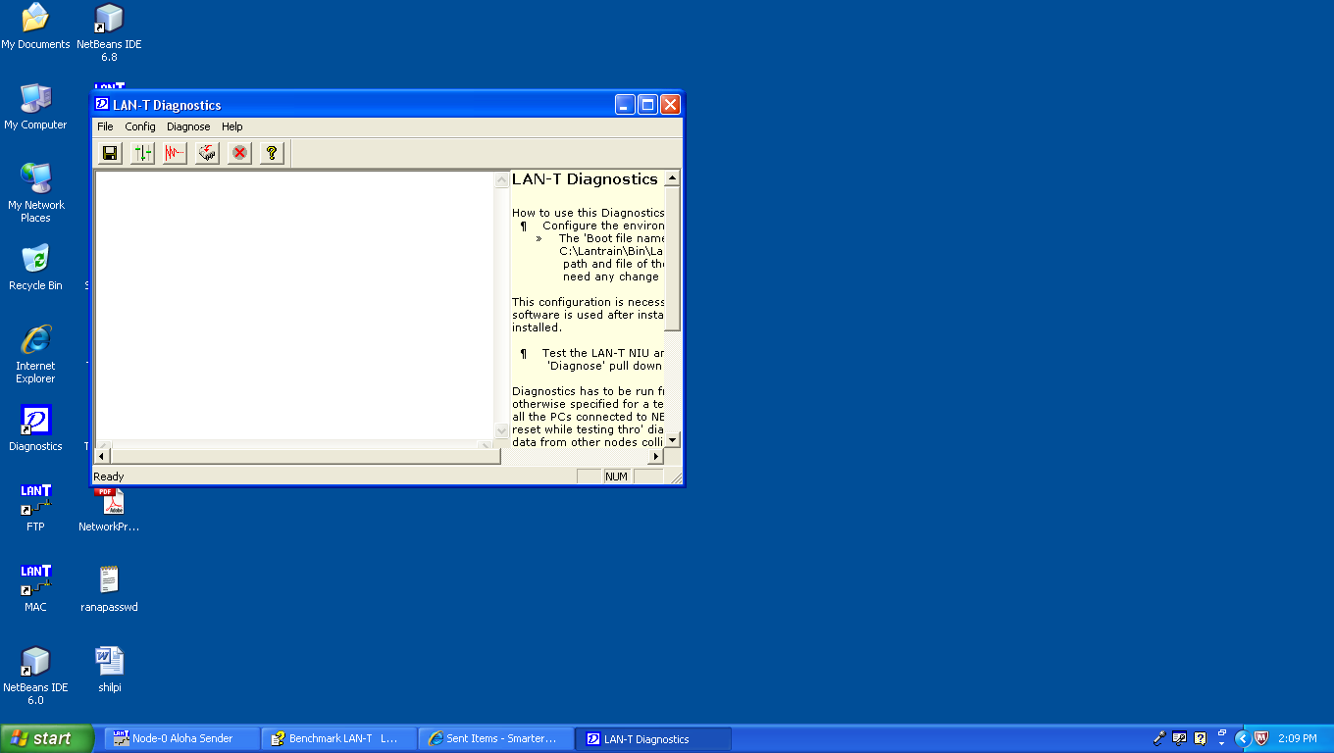
Fig 1:Interface of LAN TKIT
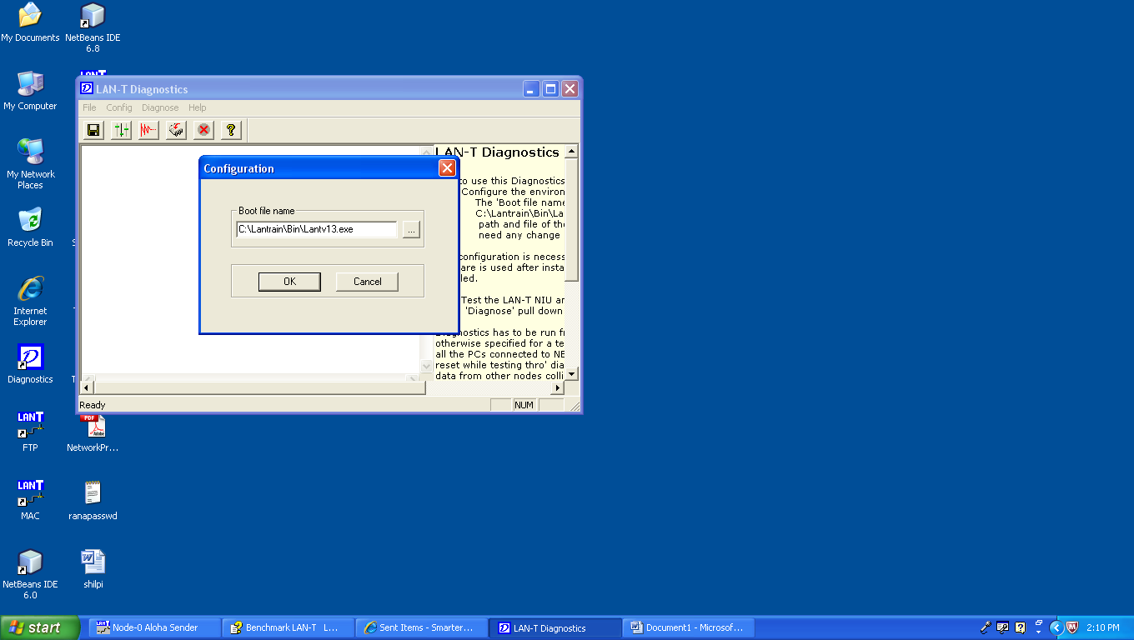
Fig 2: Configuration Interface of LAN TKIT

System Requirements & Packing List

System Requirements

PC : | Pentium II or higher  One PCI slot (32-bit) required.  (For Star related experiments that may be  developed by user, 2 slots are required in one of the PCs)  Minimum RAM as recommended by OS or by VC++ if installed
Operating System : | Windows 98 2nd Edition, Windows 2000 Professional
Number of PCs : | 2 – 3
VC++ compiler : | Version 6.0 or above  (Optional – for programming/modifying experiments, to do suggested exercises etc.,)

Packing List
Description | Qty
Network Emulator Unit (NEU) | 1 No
Network Interface Unit (NIU) | 3 Nos
LAN-T Power Supply (LAN-T PS) | 1 No
5-pin DIN cable (# 9915001) | 1 No
NIU-NEU Interface cable (# 9915002)  (D37 – D37 flat cable) | 3 Nos
Patch chords (# 9915003) | 1 Set
Manuals  (Installation manual, Programmer’s manual,  User manual) | 1 Set
Software CD | 1 No

The LAN-T CD contains self-installable software. It also contains device driver files for the NIU card that required while installing them. A setup screen appears when the CD is inserted in the CD ROM drive. Follow the instructions and complete the installation. If the setup screen does not appear, try one of the following:
1) Double click “My Computer” icon in the desktop and double click on the CD drive icon.
2) Type “D:\Setup” in the Run command. Substitute the actual CD drive letter in place of D.

The installation drive and path is defined to be C:\Lantrain by default. Leave this as such and proceed with the installation.
This installation creates Lantrain directory under C drive and copies all the software and necessary DLLs. It also creates LAN-T folder and shortcuts under Start-Programs menu and on the desktop.
The Lantrain directory contains all of the sub-directories and the files as given in the user manual (Introduction chapter). The BIN sub-directory contains some of the executable experiments that can be used to start those experiments. All other sub-directories and files are used while using with VC++.
The complete installation will take about 140MB of hard disk space. This includes the intermediate files generated by VC++ in “Debug” directory under each project (experiment). These intermediate files are created while compiling the source code in VC++. If the VC++ is not used then these intermediate files may be removed to save hard disk space.
Following experiment and diagnostics shortcuts are created on the desktop for easy accessing after installation:
- PKT
- MAC
- Token Bus
- Token Ring
- Stop Wait
- Sliding Window
- FTP
- Diagnostics
Softcopy of LAN-T manual in CHM format is available under the Start-Programs-LAN-T menu. All the LAN-T manuals are given here.

NIU card Installation

One 32-bit PCI slot is required in the PC to install each NIU card. Switch off the PC and plug-in the NIU card in a free PCI slot.
Connect one end of the NIU-NEU interface cable (Part# 9915002) to the NIU card. The other end has to be connected to the NEU either at “Node1 & 2” or “Node 2 & 3” or “Node 3 & 4” connector (at the rear of the NEU)
Switch on the PC. It will detect the card automatically and initiates driver installation wizard. Follow the steps and complete the installation. LAN-T CD contains the NIU device driver files. Keep this CD in the CR-ROM drive while installing the driver. Following are the steps that the wizard passes through and the recommended selections to install NIU successfully:
Step 1: The system detects the NIU PCI card as PCI Bridge. Click "Next".
Step 2: Select the Option "Search for the best driver for your device (recommended)" and click "Next".
Step 3: select CD-ROM check box and click "Next". Wizard will look for the *.inf file and the driver files in the LAN-T CD
Step 4: "Benchmark LANT_NIU: Device Driver" will be displayed along with the location of the INF file. Click "Next".
Step 5: Click "Finish" to complete the device driver installation.
After installing the software as given in chapter 2, run “Activate NIU” from the LAN-T program folder created under the Start-Program menu. This activates the NIU by adding and registering the driver files to the list of drivers that Windows 98 or Windows 2000 loads when it starts. Reboot the system when this program prompts to do so.
Install other NIUs in other PCs and connect to the NEU as said above.

NEU Installation

- Connect the power supply to the NEU using the 5-pin DIN cable (part# 9915001) provided with the Trainer. Connect the power supply to the AC outlet using a standard power cord. LAN-T power supply has an IEC type power socket for AC input and accepts universal supply voltages. Switch on the power supply.

2. Connect the NIUs to the NEU through the NIU-NEU flat Interface cable (part# 9915002).

3. Switch on the power to the NEU. The switch is at the rear panel of NEU.
LEDs will glow as follows:
Data Rate = 8Kbps
Topology = BUS
BER = 0
FER = 0
Delay = 0 bit
This is the default NEU condition while power-on or while reset.
  - To Emulate BUS/RING/STAR topology, press the Topology switch until the corresponding LED glows. During Power-on, the NEU emulates BUS topology.

5. To introduce Bit Errors, press the BER switch until the corresponding LED glows.
Similarly press
- FER switch to introduce Frame errors,
- Delay switch to introduce bit delays (0 to 15 bits) between the nodes and
- Data Rate switch to set the data rate between 8Kbps and 1Mbps.
Bit errors and Frame errors are introduced between nodes 2 & 3 only. Delay can be introduced between the nodes and it depends on how the nodes are interconnected.
6. Use patch cords (part# 9915003) to interconnect various elements like nodes, delay blocks, error generating blocks etc., in the NEU. Each node (with transceiver) in NEU has an Input, an Output, a Tx port and Rx port. Each delay has an input and output port.

Patch cord connections to setup a BUS network:
To connect nodes to the medium (BUS):
Connect posts N1 to T11, N2 – T21, N3 – T31, N4 – T41, N5 – T51, N6 – T61
To connect node output to its next delay input:
Connect posts T13 – D11, T23 – D21, T33 – D31, T43 – D41, T53 – D51, T63 – D61
To connect delay output to the its next node input:
Connect posts D12 – T22, D22 – T32, D32 – T42, D42 – T52, D52 – T62

Patch cord connections to setup a RING network:
Connect posts to emulate BUS network. Connect D62 – T12. This closes the loop and forms a Ring network.

Patch cord connections to setup a STAR network:
To connect nodes to the medium (BUS):
Connect posts N1 to T11, N2 – T21, N3 – T31, N4 – T41, N5 – T51, N6 – T61
To connect node output to its next delay input:
Connect posts T13 – D11, T23 – D21, T33 – D31, T43 – D41, T53 – D51, T63 – D61
To connect delay output to the Star master:
Connect posts D12 – S1, D22 – S2, D32 – S3, D42 – S4
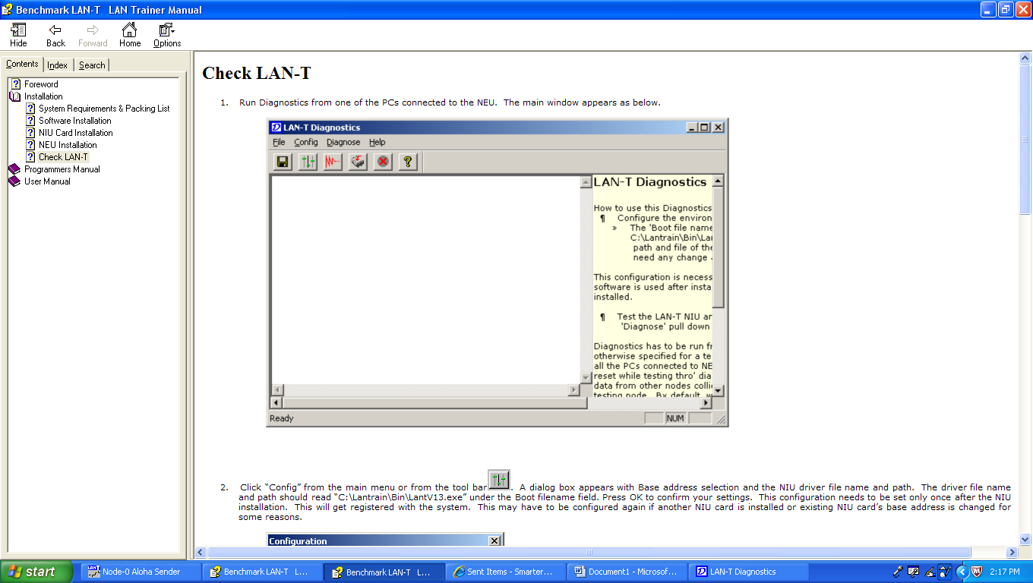
Fig 3:Check LAN TKIT

Introduction

The Benchmark LAN-T LAN Trainer consists of a Network Emulator Unit (NEU), PC Plug-in Network Interface Units (NIU) and Win95 based experiment software. The software contains a series of experiments in the form of stand-alone applications; ‘C’ source code for the experiments, and a NIU Library.
The NEU emulates 6 nodes, which can be configured to Bus, Ring or Star topologies. It also has error generators and delay generators between nodes.
Each NIU card emulates two independent network nodes supporting various MAC layers, on a single PC.
The NIU library provides a programming interface similar to that provided by typical Ethernet and other network adapters. This is register based, with command, data and status registers. These can be accessed via a set of C functions: NIU_Data(), NIU_Statistics etc.,

Frame Format

The format of the data frames used in the LAN-T is shown in Figure 1.1

1 Byte | 1 Byte | 0-998 Bytes | 2 Bytes | 2 Bytes
DA | SA | DATA | Checksum | Delimiter

Figure 4: LAN Trainer Frame Format
DA Destination Address
SA Source Address
DATA Data portion can be from 0 - 998 bytes

Checksum Checksum field is generated internally by the NIU library. The Library interface will generate the checksum while transmission, and also strip the checksum on reception. As far as the student is concerned this field is insignificant.
Delimiter Used internally for detecting the end of frame.

Guide to the LAN Trainer

To successfully use the LAN Trainer, a number of hardware and software components must be properly used together (see Fig. 1.1). Each PC acts as two nodes in the network. Both are connected to the Network Emulator Unit via the same cable. Thus, with 3 PCs, you can experiment with a 6-node network. On the software side, the screen is divided into 2 windows, one for each node. This is accomplished using the LAN Trainer control panel running under Windows - 95

NIU Card
Each PC that is part of the LAN Trainer setup must have an NIU Card plugged into it. This card has two independent full-duplex serial channels each of which can operate at data rates between 8 Kb/s and 1 Mb/s. The card supports DMA as well as programmed I/O data transfers. With one such card, a PC acts as two independent network nodes.
Once it is properly installed, the Serial Card should not require further attention. The data rate is set from the Network Emulator Unit, and all other parameters can be set by software.

Network Emulator Unit

The Network Emulator Unit acts as a network interconnecting upto 6 network nodes (3 NIU Cards in 3 PCs). Each card is connected to the Network Emulator Unit via a cable with DB-37 connectors. Once properly installed, these should not normally be disturbed. The Network Emulator Unit has a number of jumpers that must be properly wired-up depending on the type of network one wants - a bus, a ring, or a star. This must correspond to the setting of the Topology selector switch. The Network Emulator Unit also has selector switches for Data Rate, Bit Delay, Error Rate and Frame Error Rate. These should be set in accordance with the instructions of each experiment. In addition, there is a Reset switch which should be used before every experiment, and in case of trouble.

NIU Library
Above the hardware is a library of C functions that provides a programming interface to the LAN Trainer, similar to that provided by typical Ethernet and other network adapters. This emulated NIU is register-based, with command, data and status registers. These can be accessed via a set of C functions: NIU_Cmd(), NIU_Data() and NIU_Status(). The NIU library also provides a comprehensive set of interrupts.

Application Software

The final component in any experiment is the application software. This uses the facilities of the NIU library to accomplish some communication task, such as transferring a message from one node to another. Each of the two nodes on each PC can have its independent application software. Your programs will be at this level.

The Physical Links

The simplest network connecting two computers A and B is an electrical link directly from one to the other. Each computer has a network interface unit (NIU) with a transmitter and a receiver. A packet is transmitted by one computer as a sequence of bits and received by the other in the same order. Depending on the time it takes to transmit one bit, the link has a capacity or bandwidth of C b/s (bits per second).
We can extend this network to accommodate a third computer, C, by adding a second NIU in each computer and two more links (Fig. 2.4 b). Each computer can send a packet to either of the others at any time by transmitting it on the appropriate link. This type of interconnection, referred to as a complete mesh topology, can be extended to connect N computers. Every computer must have (N-1) NIUs and the total number of links is N(N-1)/2 (Fig. 2.5 a). Thus, the benefit of never having to wait to transmit is outweighed by the large number of NIUs and links except when the number of computers, N, is small, say 3 or 4.

To reduce the number of links, every node is connected to one central node in the star topology (Fig. 2.5 b). A packet between any two nodes may need two hops via the central node. If the central node is the source or the destination, only one hop is required. The central node is a single point whose failure renders the entire network inoperative. In cases where most communication is between one server and its clients, the star topology is especially useful.
The single point of failure can be avoided by using the ring or bus topology (Fig. 2.5 c and d). In the ring, every computer is attached to a circular cable. As a packet circulates around the ring, it can be received by every node. To avoid the packet circulating indefinitely, it is removed by the

transmitting node after one round. In order to handle these functions, the attachment is via an electronic circuit called a transceiver. The transceiver is a complex device and may fail unless carefully designed.
In the bus topology, the network is a single cable, with no active devices. Each node is connected to it via a simple tap. This can be very reliable and inexpensive. Owing to its simplicity and reliability, the bus is the most popular topology for local area networks. Ethernet, the most widely used LAN uses the bus topology.
Like the ring, the bus also has the broadcast property, i.e., as a packet propagates down the bus to its ends it can be received by every node. In the mesh and star topologies, sending the same packet to every node requires that N-1 copies of the packet be separately transmitted.

Making Sense

A network allows one computer to send electrical signals to another computer. These signals have to be somehow interpreted as a stream of bits. The stream of bits has different meanings depending on the application. If one computer sends a binary file, and the other expects to receive an e-mail message, clearly proper communication will not take place. This is analogous to a Central Government official speaking in Hindi to a villager who knows only Tamil.
In order for communication to take place, both parties, be they human or computer, must agree on a set of conventions such as what signals constitute a 1 and a 0, where are the byte-boundaries in a stream of bits, how is a binary file differentiated from an e-mail message. Such a set of conventions is a protocol.
A network may include computers manufactured by different vendors with software from various sources. For these to be able to communicate, the protocols used must be agreed upon by all the manufacturers, i.e., standards are required. For example, RS-232C is a standard protocol for transmission of a stream of bytes that is widely used for sending data between computers and peripherals such as printers and modems. TCP is a standard protocol used for reliable transmission of arbitrary data between computers in the Internet.

EXPERIMENT NO.-11
To implement a routing protocol and check its connectivity in a variable length subnet masked network
Objective:
To be able to implement RIP(Routing Information Protocol) in the VLSM(Variable Length Subnet Masking) network so as to know about subnetting and dynamic configuration protocol and implement it in a real time scenario.
Software used:
CISCO Packet Tracer
Version 5.3.0.0088

Topology:
4 Routers connecting different networks connected through serial cables
3 End devices(P.C) or workstations to check the connectivity between different networks.
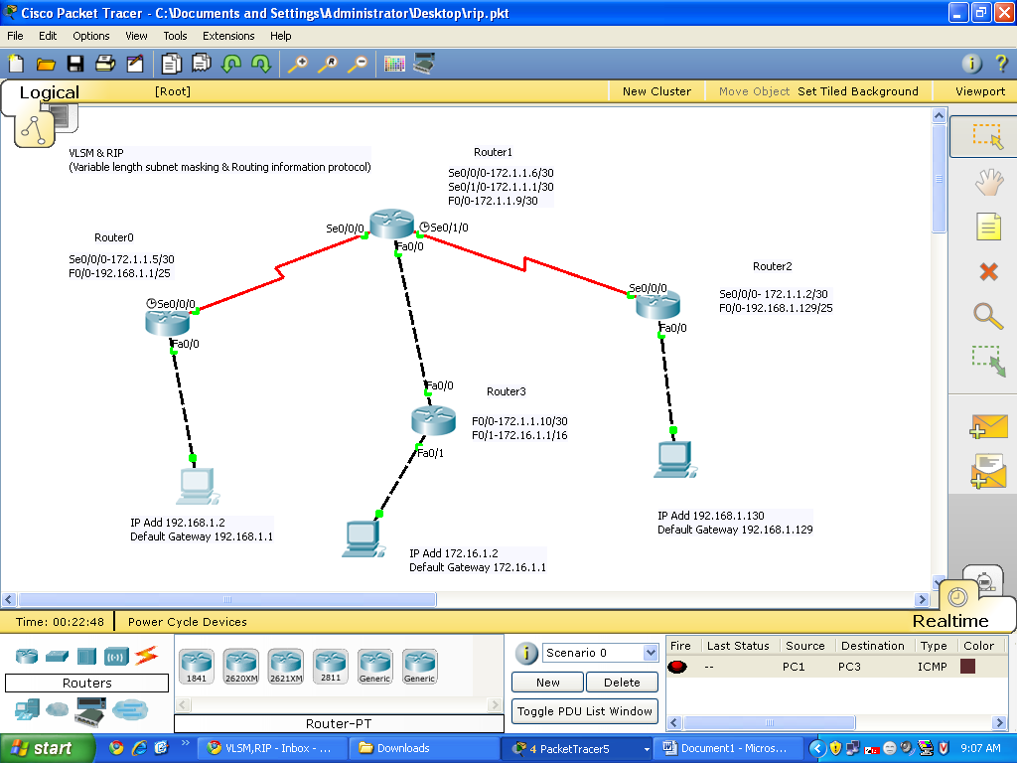
Fig 5:Packet Tracer

Router0: Se0/0/0-172.1.1.5/30 Router1: Se0/0/0-172.1.1.6/30
F0/0-192.168.1.1/25 Se0/1/0-172.1.1.1/30
F0/0-172.1.1.9/30
Router2: Se0/0/0- 172.1.1.2/30 Router3: F0/0-172.1.1.10/30
F0/0-192.168.1.129/25 F0/1-172.16.1.1/16
PC1: IP Add 192.168.1.2
Default Gateway 192.168.1.1

PC2: IP Add 172.16.1.2
Default Gateway 172.16.1.1

PC3: IP Add 192.168.1.130
Default Gateway 192.168.1.129

Theory & Implementation on the above taken Topology
IP Address
An IP address consists of 32 bits of information. These bits are divided into four sections, referred to as octets or bytes, each containing 1 byte (8 bits). You can depict an IP address
using one of three methods:
Dotted-decimal, as in 172.16.30.56
Binary, as in 10101100.00010000.00011110.00111000
Hexadecimal, as in AC.10.1E.38
Summary of the three classes of networks
8 bits 8 bits 8 bits 8 bits
Class A: Network Host Host Host
Class B: Network Network Host Host
Class C: Network Network Network Host
Class D: Multicast
Class E: Reserved for future

Classfull IP address
Is divided into 5 major groups
- Class A
- Class B
- Class C
- Class D
- Class E

Class A, B and C are used in networking
Class D is used for broadcasting
Class E is reserved for the future

The following table shows the range of IPv4 addresses for all classfull type
Class A (0-127).(0-255).(0-255).(0-255)
Class B (128-191).(0-255).(0-255).(0-255)
Class C (192-223).(0-255).(0-255).(0-255)
Class D (224-239).(0-255).(0-255).(0-255)
Class E (240-255).(0-255).(0-255).(0-255)
Note : 127.0.0.0 is reserved for loopback testing.

IMPORTANT NOTE : Subnetting :Subnetting is essentially the modification of a single IP network to create two or more logically visible sub-sections. It entails changing the subnet mask of the local network number to produce an even number of smaller network numbers, each with a corresponding range of IP addresses.
Subnetting is required when one network number needs to be distributed across multiple LAN segments. This may be the case in instances when:.
- Two network segments are restricted by distance limitations (for example, remote offices linked via point-to-point circuit).
- Segments need to be localized for network management reasons (accounting segment, sales segment, etc.).
- Hosts which dominate most of the LAN bandwidth need to be isolated.
RIP(Routing Information Protocol)
The key characteristics of RIP include the following:
-  RIP is a distance vector routing protocol.
-  Hop count is used as the metric for path selection.
-  The maximum allowable hop count is 15.
-  Routing updates are broadcast every 30 seconds by default.
-  RIP is capable of load-balancing over as many as sixteen equal-cost paths. (Four paths is the default.)

To enable a dynamic routing protocol, you must complete the following steps:
Step 1 Select a routing protocol: RIP, EIGRP, or OSPF.
Step 2 Assign IP network numbers without specifying subnet values (except for OSPF).
IMPORTANT NOTE: You must also assign network or subnet addresses and the appropriate subnet mask to the interfaces.

RIP Configuration
The router rip command selects RIP as the routing protocol.

RouterX(config)# router rip
Starts the RIP routing process

RouterX(config-router)# version 2
Enables RIP version 2

RouterX(config-router)# network network-number
Selects participating attached networks
Requires a major classful network number

The network command assigns a major network number that the router is directly connected
to. The RIP routing process associates interface addresses with the advertised network number
and will begin RIP packet processing on the specified interfaces.

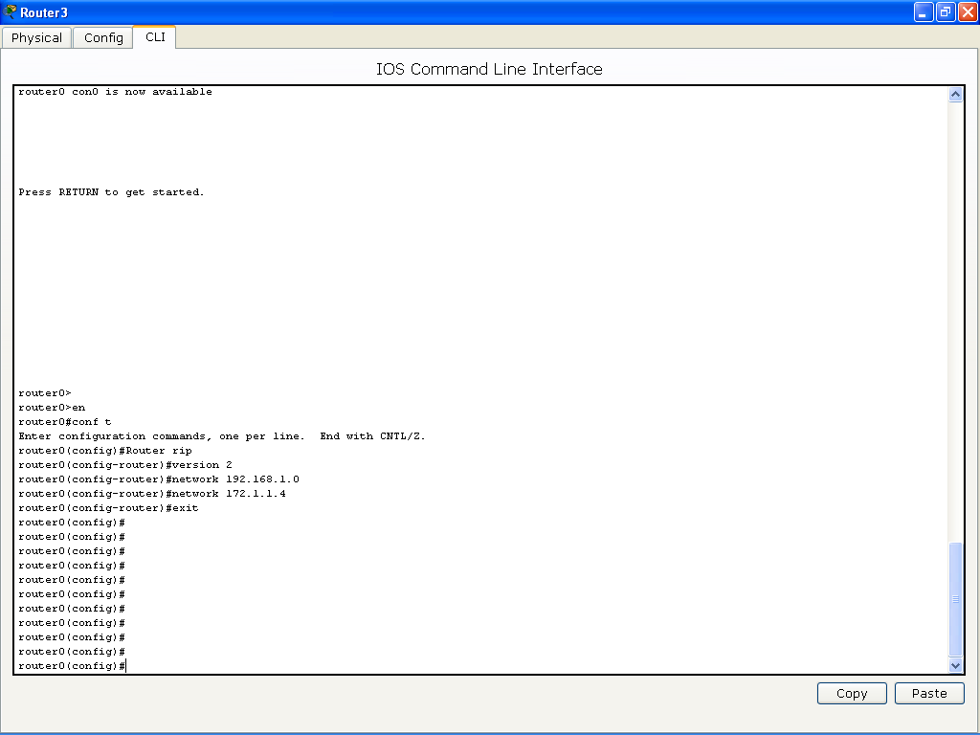
Fig 6:Interface
Verifying the RIP Configuration
The show ip protocols command displays values about routing protocols and the routing
protocol timer information that is associated with the router.
The table describes the significant fields shown in the display.
Field Description
Routing Protocol is "rip" Specifies the routing protocol used

Sending updates every 30 Specifies the time between sending updates
seconds

next due in 6 seconds Specifies when the next update is due to be sent

Invalid after 180 seconds Specifies the value of the invalid parameter

hold down 180 Specifies the current value of the hold-down parameter
flushed after 240 Specifies the time (in seconds) after which the individual routing information will be thrown (flushed) out

Outgoing update Specifies whether the outgoing filtering list has been set

Incoming update Specifies whether the incoming filtering list has been set

Redistributing Lists the protocol that is being redistributed

Default version control Specifies the version of RIP packets that are sent and received

Routing Specifies the networks for which the routing process is currently injecting routes

Routing Information Sources Lists all the routing sources that the Cisco IOS Software is using to build its routing table. For each source, you will see the following displayed:
■ IP address
■ Administrative distance
■ Time the last update was received from this source

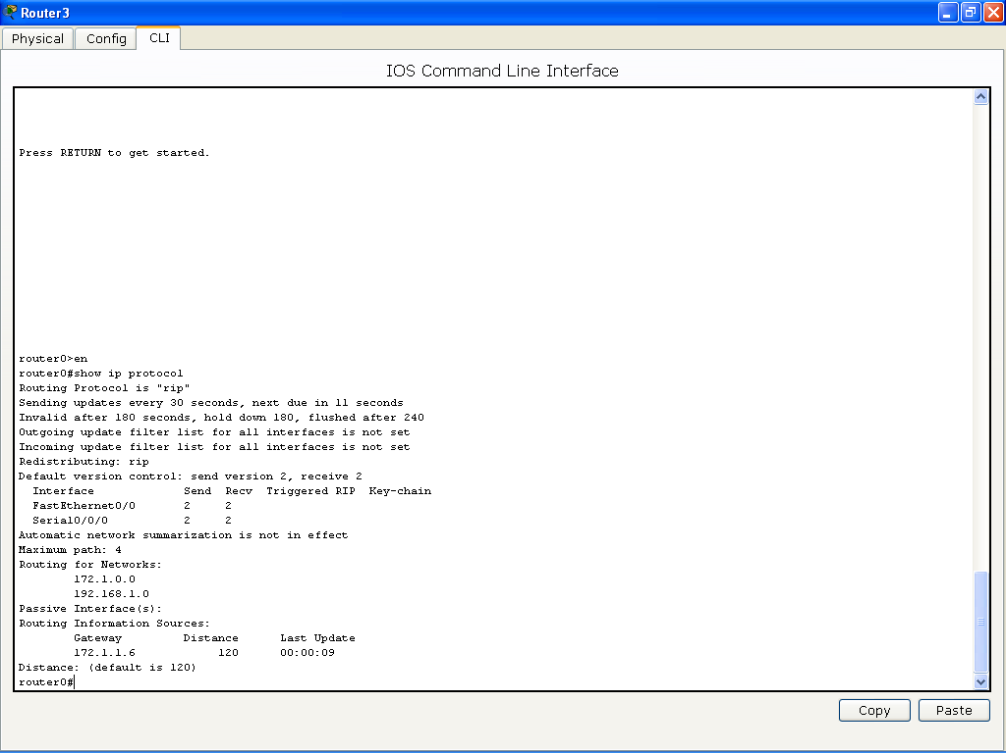
Fig 7:Interface
Displaying the IP Routing Table
The show ip route command displays the contents of the IP routing table.
The routing table contains entries for all known networks and subnetworks, and a code that
indicates how that information was learned. The output and function of key fields from the
show ip route command are explained in the table.
Output Description
R or C Identifies the source of the route. For example, a “C” indicates that the route came from a direct connection of the route to a router interface. An “R” indicates that RIP is the protocol that determined the route.

192.1.1.0 Indicates the address of the remote network.
172.1.1.8
192.168.1.128

120/1 The first number in the brackets is the administrative distance of the information source; the second number is the metric for the route (here, 1 hop).

via 10.1.1.2 Specifies the address of the next-hop router to the remote network.

00:00:07 Specifies the amount of time since the route was updated (here, 7 seconds).

Serial0/0/2 Specifies the interface through which the specified network can be reached.

If routing information is not being exchanged (that is, if the output of the show ip route
command shows no entries that were learned from a routing protocol), use the show runningconfig
or show ip protocols privileged EXEC commands on the router to check for a possible
misconfigured routing protocol.

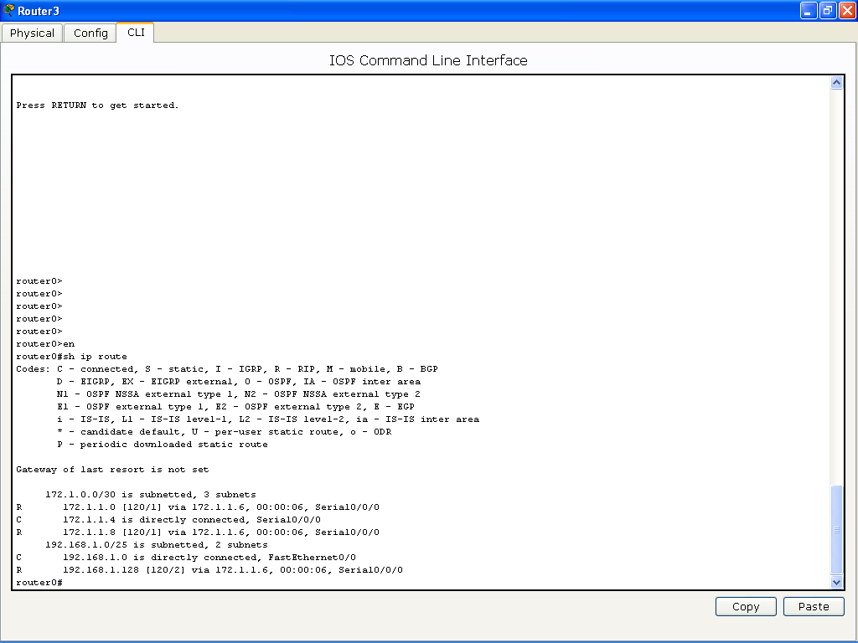
RIP Configuration Troubleshooting
Use the debug ip rip command to display RIP routing updates as they are sent and received.
The no debug all command turns off all debugging.

The following output indicates the source address from which updates were received:
RIP: received v1 update from 10.1.1.2 on Serial0/0/2
The following output indicates the destination addresses to which updates were sent:
RIP: sending v1 update to 255.255.255.255 via FastEthernet0/0
(172.16.1.1)
RIP: sending v1 update to 255.255.255.255 via Serial0/0/2
(10.1.1.1)

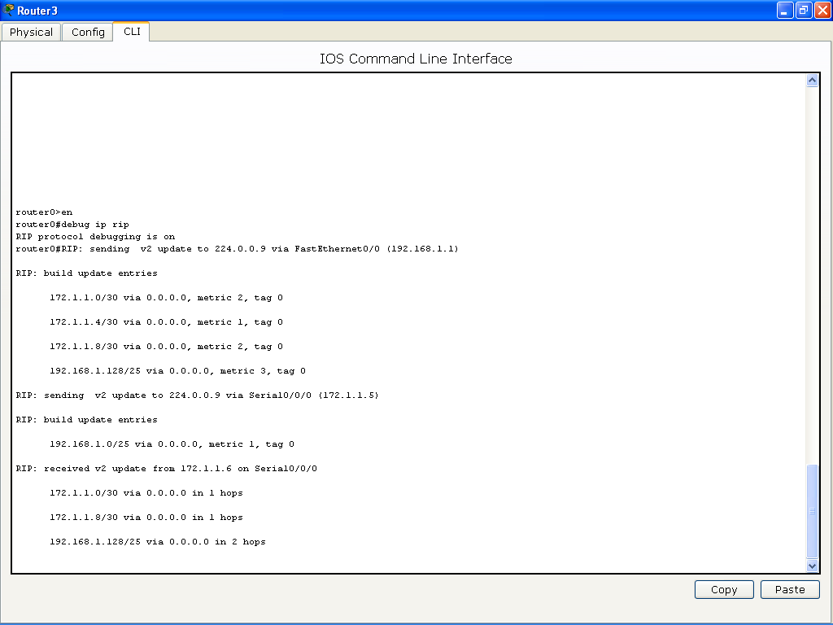

To check the connectivity between the different work stations
we use the ping command
example we ping the system 192.168.1.130/25 from 192.168.1.2/25

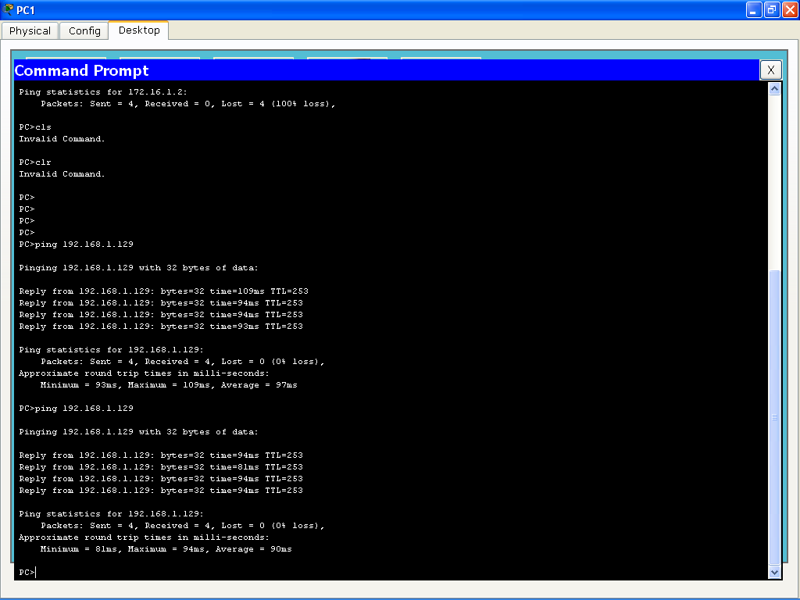

EXPERIMENT NO.-12

: How Many Networks?

Learning Objectives
Upon completion of this lab, you will be able to:
Determine the number of subnets.
Design an appropriate addressing scheme.
Assign addresses and subnet mask pairs to device interfaces.
Examine the use of the available network address space.

Scenario
In this lab, you have been given the network address 192.168.26.0/24 to subnet and provide the IP addressing for the networks shown in the Topology Diagrams. You must determine the number of networks needed then design an appropriate addressing scheme. Place the correct address and mask in the Addressing Table. In this example, the number of hosts is not important. You are only required to determine the number of subnets per topology example.
Topology Diagram A
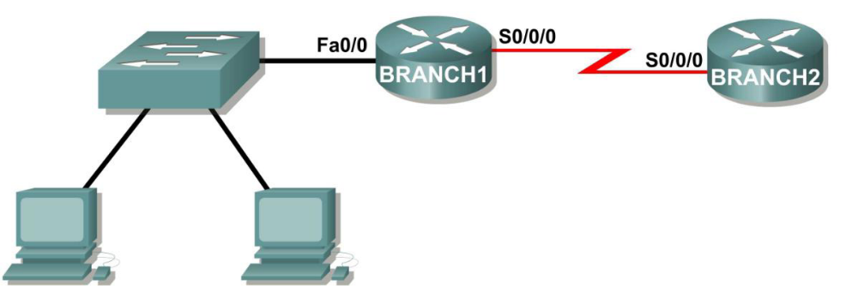

Task 1: Determine the Number of Subnets in the Topology Diagram.
Step 1: How many networks are there? __2__
Step 2: How many bits should you borrow to create the required number of subnets? __1__
Step 3: How many usable host addresses per subnet did this give you? __126__
Step 4: What is the new subnet mask in decimal form? ___255.255.255.128_____
Step 5: How many subnets are available for future use? __0__

Task 2: Record Subnet Information.
Step 1: Fill in the following chart with the subnet information.

Subnet Number
Subnet Address
First Usable
Host Address
Last Usable
Host s
Broadcast
Address

Topology Diagram B

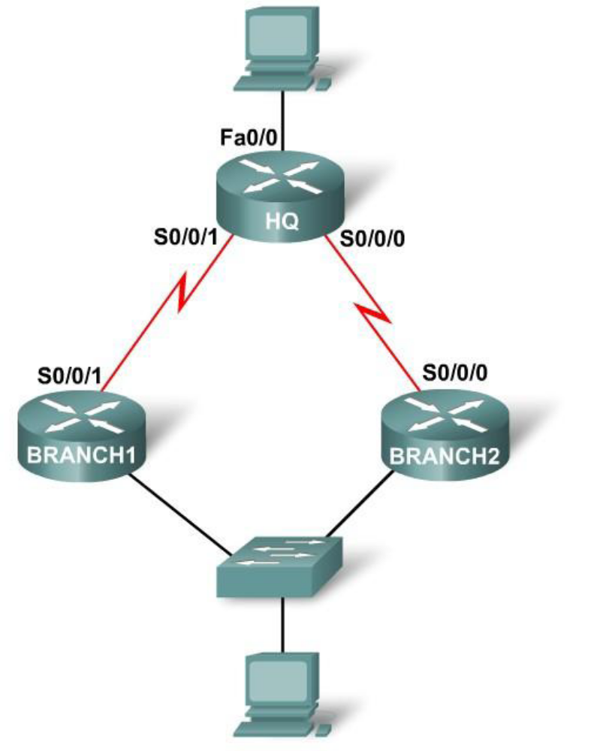
Task 3: Determine the Number of Subnets in the Topology Diagram.
Step 1: How many networks are there? __4__
Step 2: How many bits should you borrow to create the required number of subnets? __2__
Step 3: How many usable host addresses per subnet did this give you? __62__
Step 4: What is the new subnet mask in decimal form? _____255.255.255.192____
Step 5: How many subnets are available for future use? __0__

Task 4: Record Subnet Information.
Step 1: Fill in the following chart with the subnet information.
Subnet
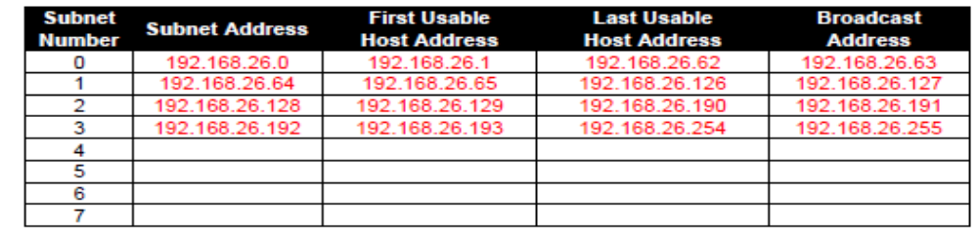Number
Subnet Address
First Usable
ddress
Topology Diagram C

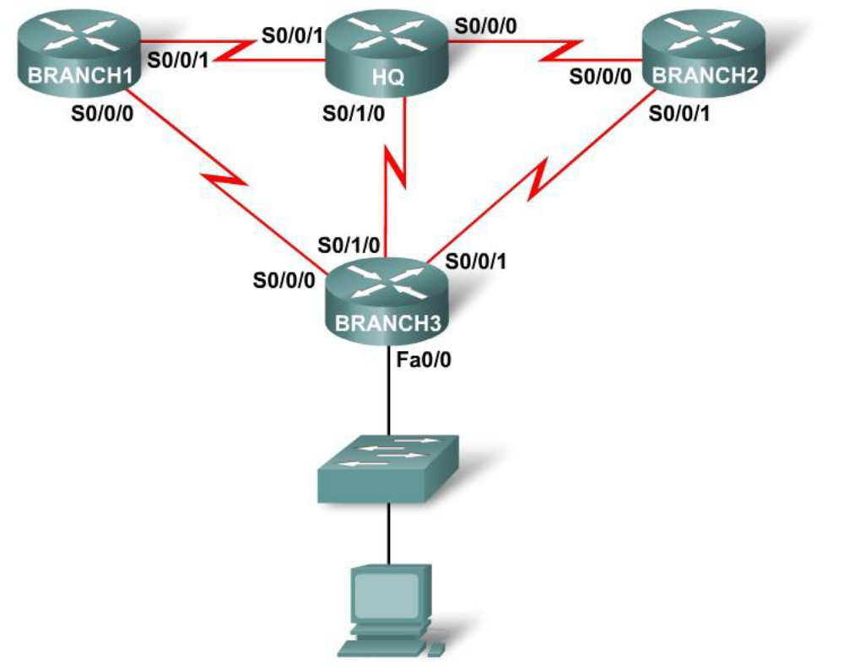

Task 5: Determine the Number of Subnets in the Topology Diagram.
Step 1: How many networks are there? __6__
Step 2: How many bits should you borrow to create the required number of subnets? __3__
Step 3: How many usable host addresses per subnet did this give you? __30__
Step 4: What is the new subnet mask in decimal form? ____255.255.255.224____
Step 5: How many subnets are available for future use? __2__
Task 6: Record Subnet Information.
Step 1: Fill in the following chart with the subnet information.
Subnet
Number
S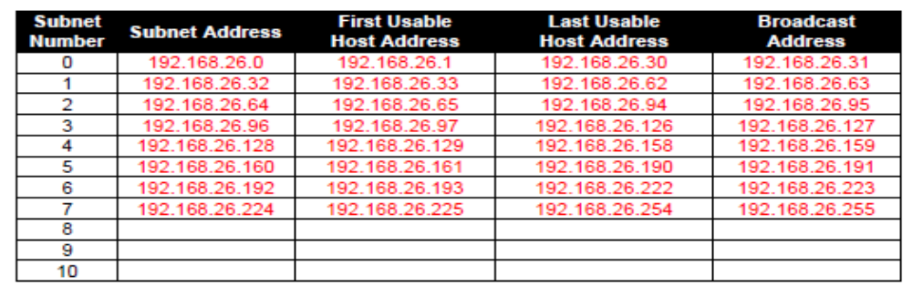ubnet Address
First
Topology Diagram D

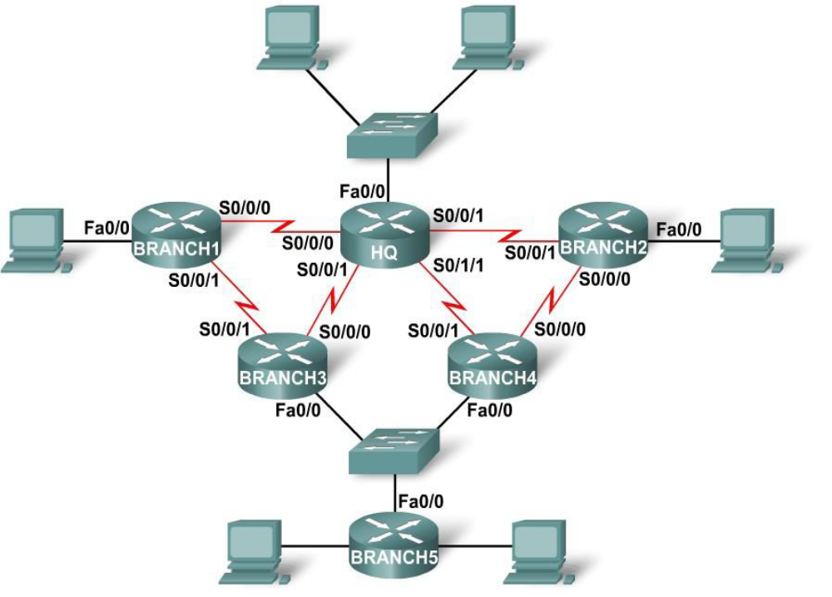

Task 7: Determine the Number of Subnets in the Topology Diagram.
Step 1: How many networks are there? __12__
Step 2: How many bits should you borrow to create the required number of subnets? __4__
Step 3: How many usable host addresses per subnet did this give you? __14__
Step 4: What is the new subnet mask in decimal form? ____255.255.255.240_____
Step 5: How many subnets are available for future use? __4__

Task 8: Record Subnet Information.
Step 1: Fill in the following chart with the subnet information.
Subnet
Numbubnet Address
Fi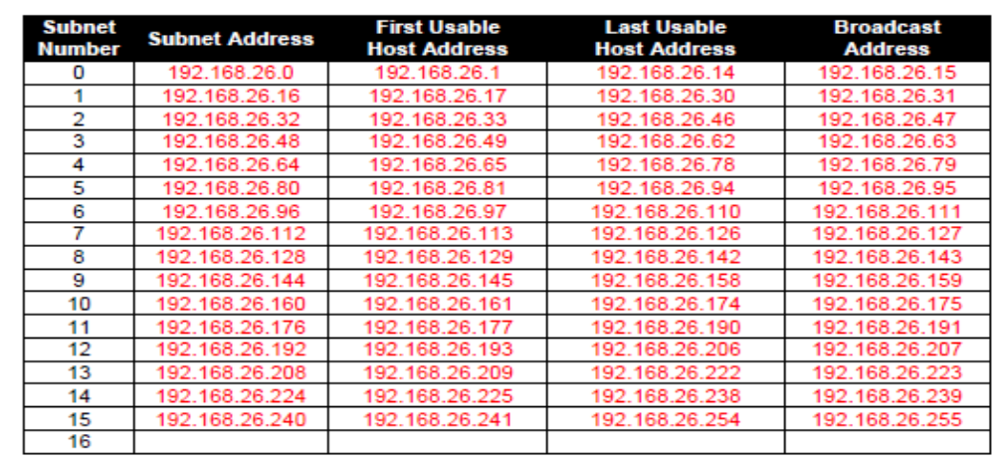rst Usable
Address
able
Broadcast
Task 9: Reflection
What information is needed when determining an appropriate addressing scheme for a network?
_____________________________________________________________________________
_____________________________________________________________________________
_____________________________________________________________________________
Number of networks and hosts are needed when determining an appropriate addressing scheme
for a network.

